**Project Design Phase-I**

**Solution Architecture**

|  |  |
| --- | --- |
| Date | 18 NOVEMBER 2022 |
| Team ID | PNT2022TMID39001 |
| Project Name | Project – AI Powered Nutrition Analyzer for  Fitness Enthusiasts |
| Maximum Marks | 4 Marks |

**Solution Architecture:**

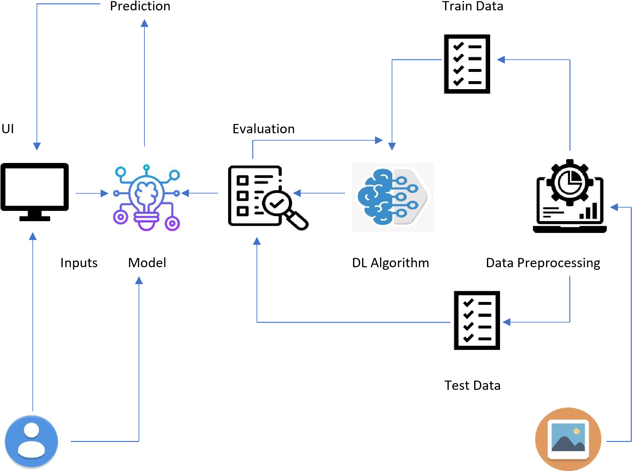

User Image Data